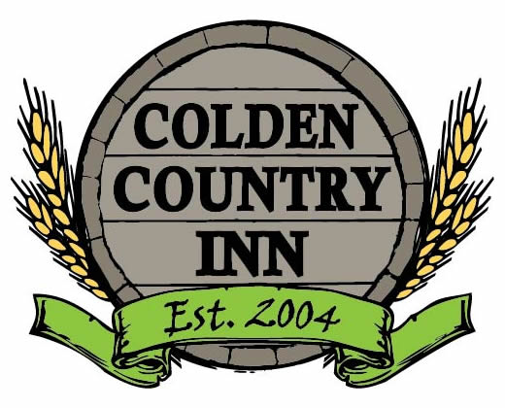
2017 Beer/Wine Fest Menu

*Short Rib Slider~ $3

Brioche Slider Roll, Asian Sesame Ginger Marinated Braised Short Ribs

*Bacon Wrapped Shrimp~ $5

In House Smoked Bacon Wrapped Shrimp, Orange Jalapeno Glaze

*BBQ Pork Belly~$4

Thick Cut Pork Belly, Crispy Fried,
Red Ale Hoisin BBQ

*Chipotle Elk Stout Chili~$4

Medium Heat Elk & Bean Chili Infused with Hints of Coffee Stout Beer & Chipotle

*Buffalo Chicken Stuffed Pepper~ $5
Hot Banana Pepper, Buffalo Chicken
Style Cheese Filled, Grilled Pita Points

*Truffle Salt Pretzel Bites~ $3

Indian Pale Ale Beer Cheese Dipping

