Buffalo Ski Club Newsletter

From the President – February 2015

Well, we had a slow start this season, but what a comeback! I hope everyone is having as much fun on the slopes as I have – I can’t remember a season with as much powder.

And not only do we have snow, but there is so much more going on this year at BSC. Races, bands, freestyle competitions, the chili contest, ladies night, instructor clinics, socializing, lesson programs, Extreme Team activities, etc., etc. I am sure I missed something, but my point is, if you are not out enjoying your club, you are missing out!

I hope you are all enjoying the improvements this season, as we continue to strive to build value and increase fun for our members. Our operations team improved equipment for better snow making. Carmen’s Catering has done a great job with the kitchen/snack bar at Tamarack. If you haven’t tried the Crème Brule French Toast, you are missing out!

There is still a lot left on the social calendar. Emily Downing has done an unbelievable job scheduling bands and parties for us. Not sure how she does it, but she now has about a dozen or so entertainers on her speed dial list!

Have you noticed the rails and other “features” on Doc’s Showoff? A group of members gathered this summer to plan and organize placement of “features” on the slopes for everyone to enjoy. There are more to come as the season goes on, provided Mother Nature continues to cooperate. Special thanks goes to Wendy and Brian Emerling, who led the charge. With the help of many others, they renovated and modified the rails at Brian’s fab shop this summer. When you see Wendy and Brian, thank them for their efforts.

While you are at it, thank all those who volunteer their time to make BSC special. We are lucky to have so many people who step up when needed to help each other, our families, and to make BSC the best and safest place to ski and snowboard.

Make sure you check out the BSC web-site for upcoming events and information for participation, in addition to trail conditions, program information, and photos. We have also posted meeting information for the Board of Directors, in case you want to attend and share ideas.

Remember, we are all owners of BSC. Let’s make sure we make the best of it! See you on the slopes!
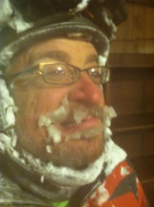
Paul Enderle
BSC Inc Board President 2014-2015 Season

